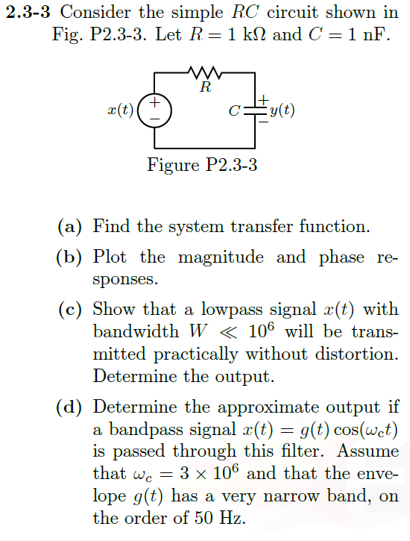

a) Use voltage division

$R→R C→ \frac{1}{Cs}$

Then, $Y\left(s\right)=X(s)\left(\frac{1/{Cs}}{R+1/{Cs} }\right)$

Or, $H\left(s\right)={\left(1+CRs\right)}^{-1}={\left(1+0.000001s\right)}^{-1}$

b) Using MATLAB, where cutoff frequency is shown with dashed lines

.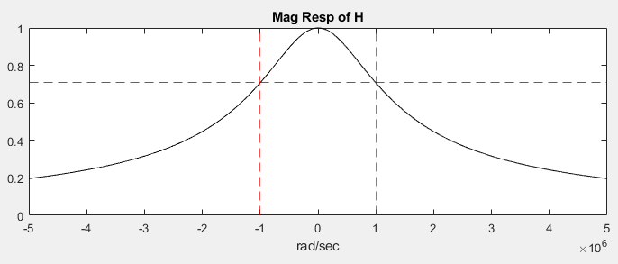

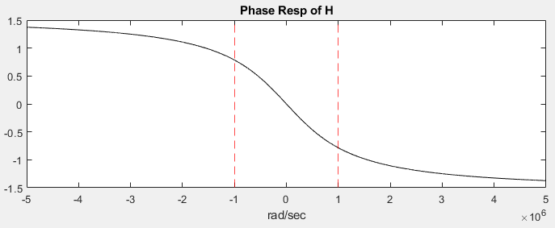

c) To transmit a signal without distortion two things are necessary

1. constant scale factor (magnitude response = constant)

2. constant delay variation (slope of phase response = constant)

Below is the Magnitude response. The scale factor changes from a minimum of 0.707 to a maximum of 1. This isn’t ideal but it is somewhat constant-ish over the pass region.

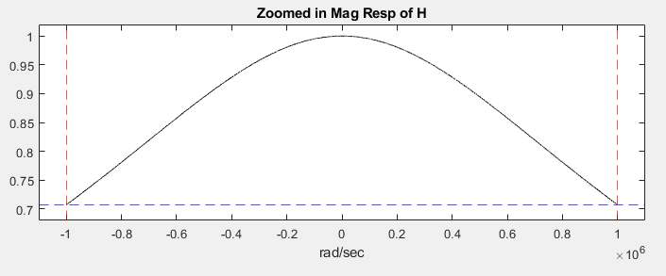

Below is the delay variation (slope of the phase delay). Over the pass band it varies from $10×{10}^{-8}\frac{rad}{{rad}/{sec}}$ $5×{10}^{-8}\frac{rad}{{rad}/{sec}}$

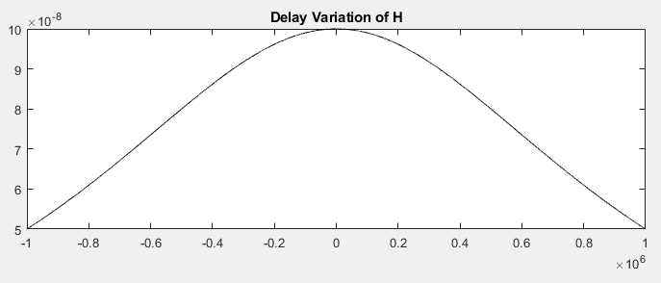

If signal $x(t)$ is inputted to this system, you could expect an output of $y\left(t\right)=Ax(t-t_{d})$

Where:

$$A=0.7071→1$$

$$t_{d}=-0.7854 rad→0.7854 rad$$

d) From page 98 in book, output should have form



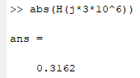

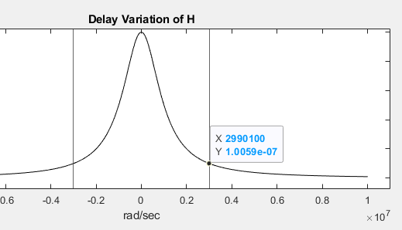

Using point slope we can find



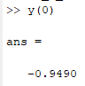

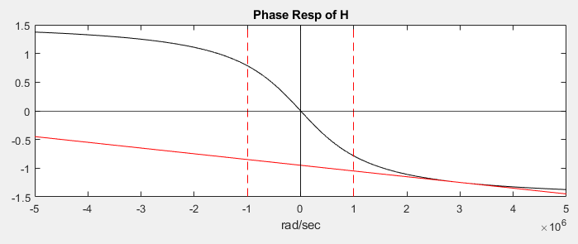

Therefore, $y_{bp}\left(t\right)=0.3162x\left(t-1×{10}^{-7}\right)cos⁡[3×{10}^{6}\left(t-1×{10}^{-7}\right)-0.949]$

